
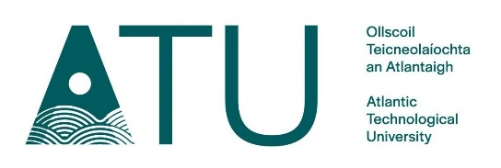

Maths Enrichment Program

Semester 1 Classes for 2024
All Classes are scheduled on Wednesdays from 7pm – 9:30pm in ATU Sligo

Class | Date | Location
1 | 9th October | E1006
2 | 16th October | E1006
3 | 23rd October | E1006
 | 30th October | No Class
4 | 6th November | E1006
5 | 13th November | E1006
6 | 20th November | E1006
7 | 27th November | E1006
8 | 4th December | E1006
9 | 11th December | E1006
10 | 18th December | E1006

The final round of the 38th Irish Mathematical Olympiad (IrMO) will be held in ATU Sligo on January 25, 2025.
For more information, please visit: https://www.itsligo.ie/mep/
$$\frac{1}{2}×\frac{5}{7}=\frac{5}{14}$$
Or email: paul.press@atu.ie
$$e^{iπ}+1=0$$
$$x=\frac{-b±\sqrt{b^{2}-4ac}}{2a}$$

